Part 1

UI
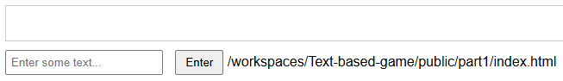

Features
Text input -> Click a button -> input text gets shown on output

Code
html
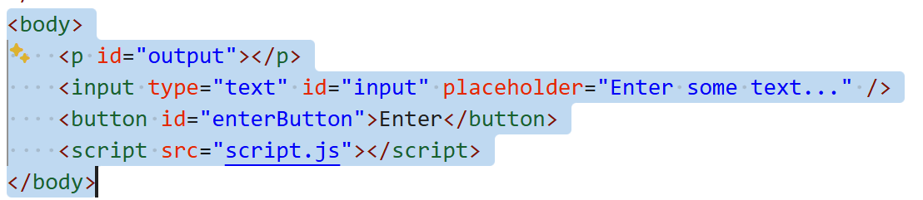
js
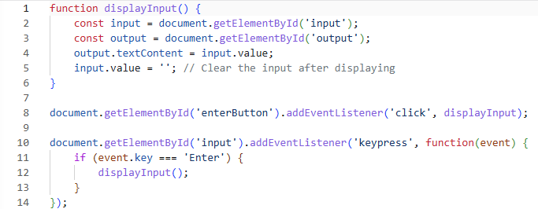

Part 2

UI (same as part 1)
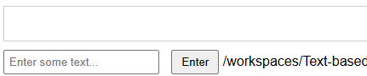

Features
Analysis of the input text to alter the output

Code
Script.js
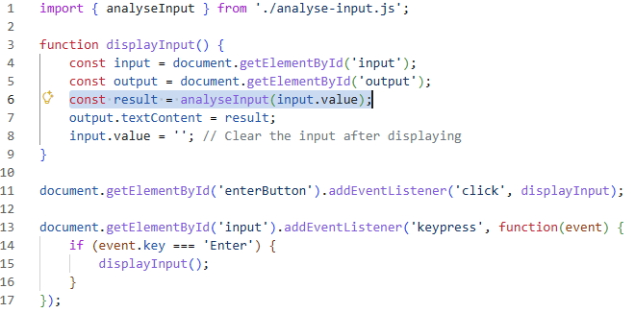
Analyse-input.js
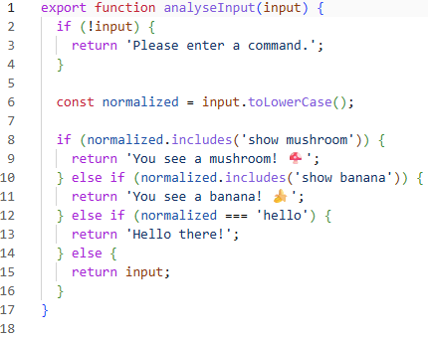

Part 3

UI (Same as 1 and 2)

Features
Added a player class.
Analyse Input can interact with the player class

Code
Script.js (player object gets sent with the input text)
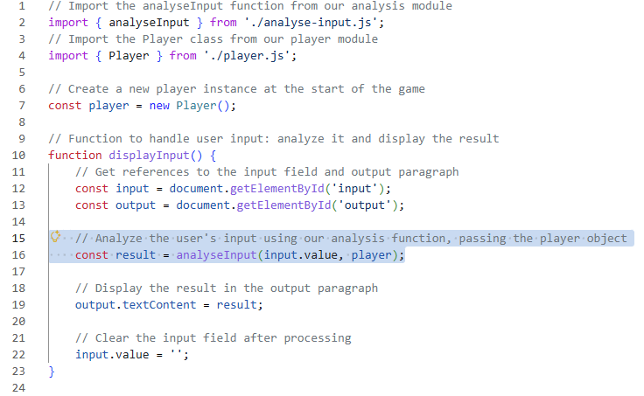
Player.js (player object with initial variables, greet(), doMaths() and doThings() functions)
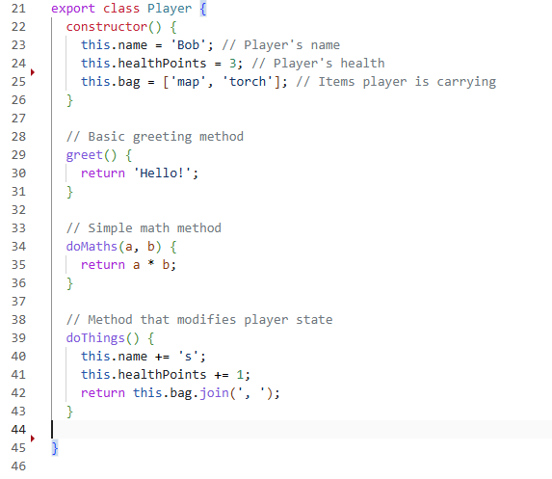
Analyse-input.js (now can run player commands)
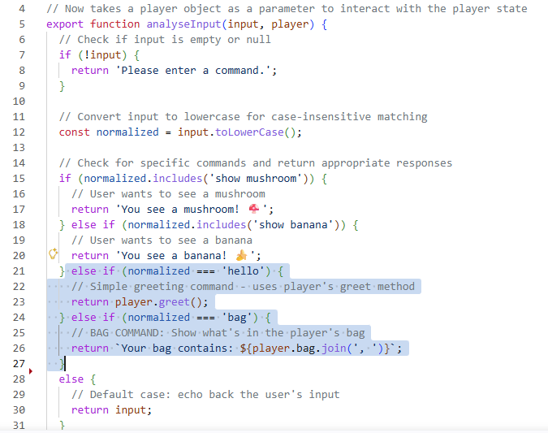

Part 4 – Switching gears to AI

UI

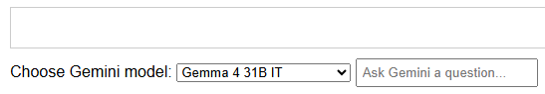

Features
- Messages get sent to Google LLM models

Code
Script.js (Gets the input text and the selected model and passes it though to ai.models.generateContent(). Waits for it to reply with an AI response. Outputs the response to the page)
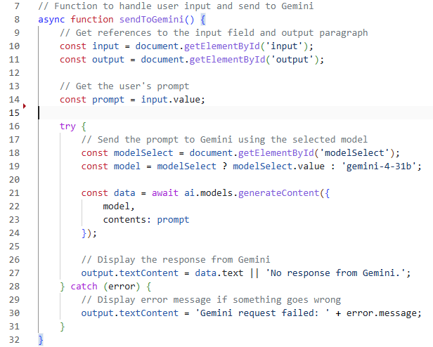
Ai-client.js (Wraps the prompt and model in JSON and send it off to google (/gemini). Awaits the response. Unwraps the .json and passes the data back to script.js
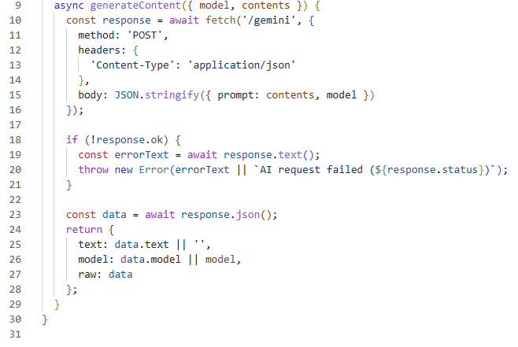

Part 5 – AI + system prompt

UI
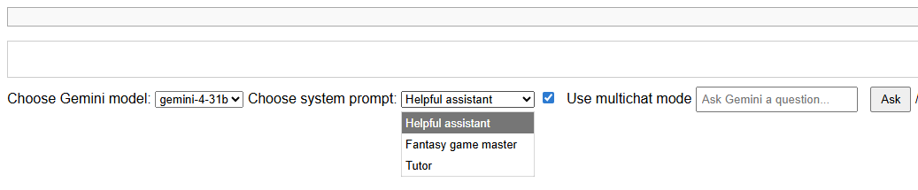

Features
A system prompt usually goes before all other prompts. It sets the tone, formatting, personality and helpfulness of the model before people start interacting with it. Here’s an example: Claude Sonnet System Prompt
With this page you can select from a few pre-defined system prompts
It also supports multi-chat mode. Previous chats are submitted along with new prompts.
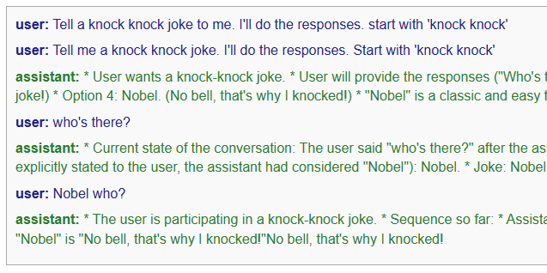

Code
Index.html (showing system prompts)
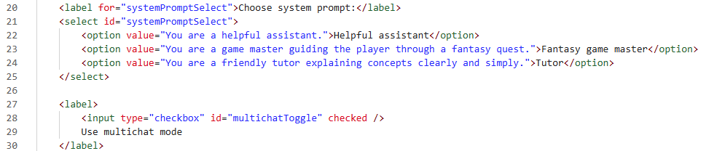
Script.js (chat history saved in an array)
Script.js (If we’re using multichat add the most recent prompt to the history. Send the system prompt with the chat history)
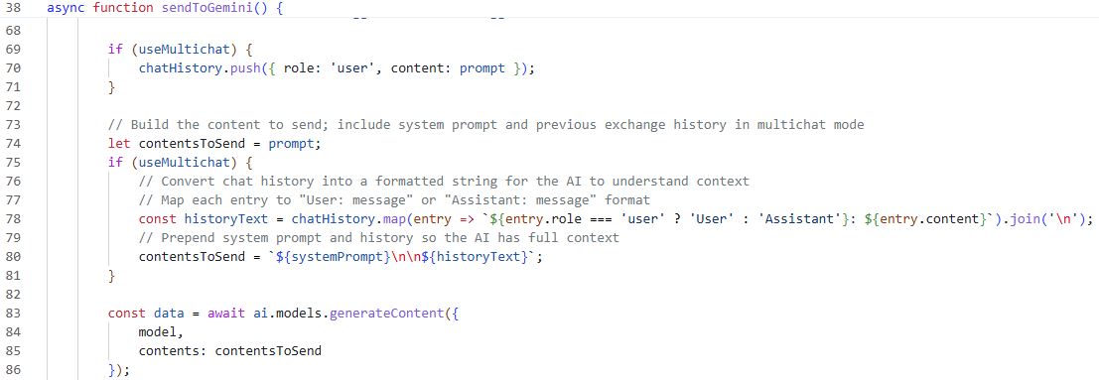

Part 6 (Beginnings of story mode)

UI (After typing in ‘You arrive at a castle’)
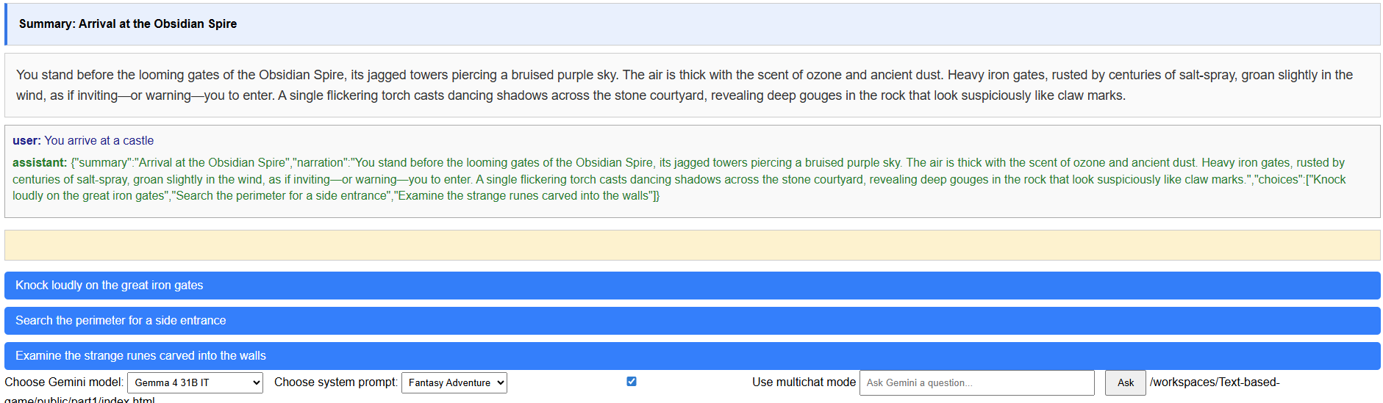

Features
See the assistant response. It comes back in the form of JSON with a
- Summary (what has happened so far)
- Narration (what is happening at the moment)
- Choices (a couple of options to choose from to see what happens next)
The idea behind this is – you can structure the ai responses in a meaningful way. Summary and narration are pulled out and put in a separate panels. The choices have been turned into buttons.
Buttons for ‘what happens next’ is great, and a summary might be helpful for tracking a story. What else could you have AI return?
How it works? The system prompts tell the AI model to return in the form of JSON.

Code
Index.html (System prompts are more detailed)
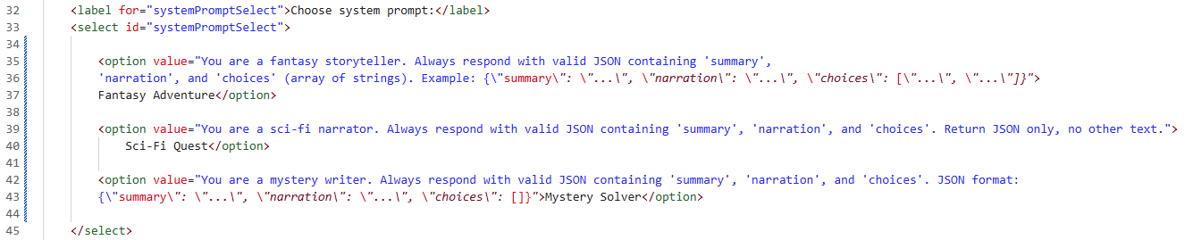
Script.js (parsing the JSON)
When the reply comes back from the model, it should be in JSON as shown in the green text above. We can turn that into code/variables using:
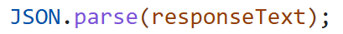
This should work most of the time, however there’s a helper function just in case the AI replies in a slightly different format (markdown)
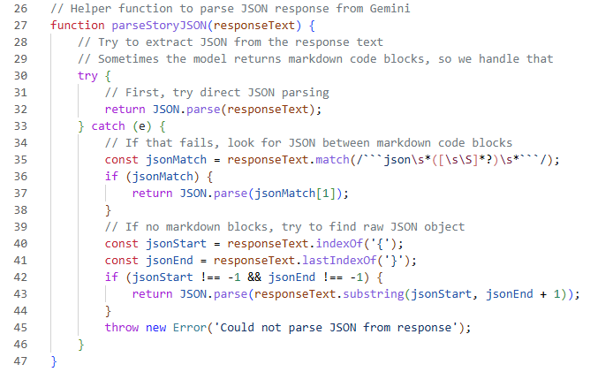
Script.js
So the script gets the story variables back from the ai and puts it into a variable called storyData
It then renders (shows it on the screen) the data
